Step By Step Guide :

1. Read the Datasets in Python,

2. Preprocess the data using multiple models

3. Do hyperparameter tuning to get the best model.

4. Once the best model with the parameters and hyperparameters is ready start then head start for the deployment.

The deployment phase involves bringing up the Application in to a webApplication Which involves the creation of the server where the code will run and render the html pages on the WebApp.

The Solution Architecture will be some thing like this:

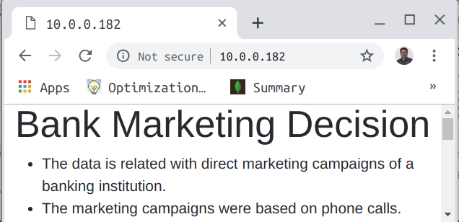
Client
Apps
Web Server
WSGI Server
Virtualenv
Flask
Template
Servers/PAaS

Operating System

Let us start with creating the web application for the above ML process we disucssed.

ENVIRONMENT CREATION:

Step1:
Creating the required environment.
i) Create a folder called bank_marketing.
ii) Create a folders inside it called data,templates and pickle

Step 2:
Create the Virtual environment using Python or conda
conda create venv
(or)
python -m venv venv

Step 3:
Activate your virtual environment using

source activate venv
(or)
source venv/bin/activate

Step 4:
Install the following packages using the requirements.txt file.

pip install -r requirements.txt

The environment required for the Web Application is ready. Now we start building the required code for the Application. The WebApplication requires the afore mentioned architecture that involves the creation of a webserver. We can create a local server using the nginx. But the nginx cannot directly connect and respond back to the Python Application we need to create a WSGI server. The roles of each of these components are discussed in the PPT session for the Use case.

Application Code Creation:

We are using Flask on the Virtualenvironment to create the application. Therefore we need to understand the functionality of Flask to create a basic micro web application.

A minimal Flask application looks something like this:

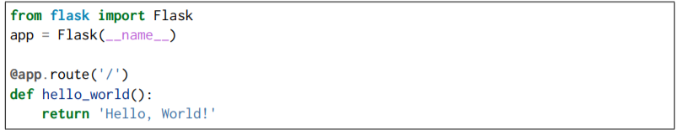

1. First we imported the Flask class. An instance of this class will be our WSGI application.

2. Next we create an instance of this class. The first argument is the name of the application’s module or package. If you are using a single module (as in this example), you should use __name__ because depending on if it’s started as application or imported as module the name will be different ('__main__' versus the actual import name). This is needed so that Flask knows where to look for templates, static files, and so on.
3. We then use the route() decorator to tell Flask what URL should trigger our function.

4. The function is given a name which is also used to generate URLs for that particular function, and returns the message we want to display in the user’s browser.

Just save it as hello.py or something similar. Make sure to not call your application flask.py because this would conflict with Flask itself. To run the application you can either use the flask command or python’s -m switch with Flask.

Before you can do that you need to tell your terminal the application to work with by exporting the FLASK_APP environment variable:

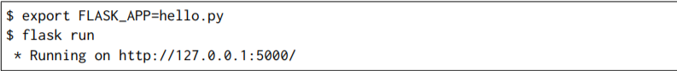

If you are on Windows, the environment variable syntax depends on command line interpreter.

On Command Prompt:
C:\path\to\app>set FLASK_APP=hello.py
And on PowerShell: PS
C:\path\to\app> $env:FLASK_APP = "hello.py"

Alternatively you can use python -m flask:
$ export FLASK_APP=hello.py
$ python -m flask run * Running on http://127.0.0.1:5000/

This launches a very simple builtin server, which is good enough for testing but probably not what you want to use in production. And also for the data we required some front end for the user to interact with the application. This will requires the templates to be rendered on the webpages and based on the user interaction we need to have the server code responding back with the apt messages. Also in the afore mentioned code there is a route function which will redirect us to different web pages. Let us understand the code further.

Routing :
Modern web applications use meaningful URLs to help users. Users are more likely to like a page and come back if the page uses a meaningful URL they can remember and use to directly visit a page. Use the route() decorator to bind a function to a URL.

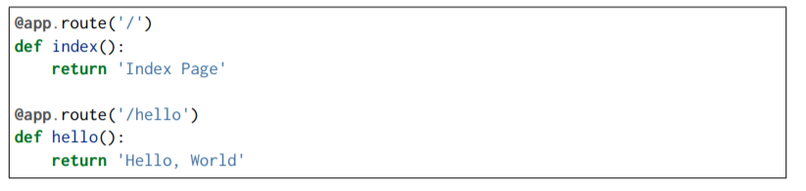
Variable Rules:

You can add variable sections to a URL by marking sections with variable names.Your function then receives the variable name as a keyword argument. Optionally, you can use a converter to specify the type of the argument like <converter:variablename>

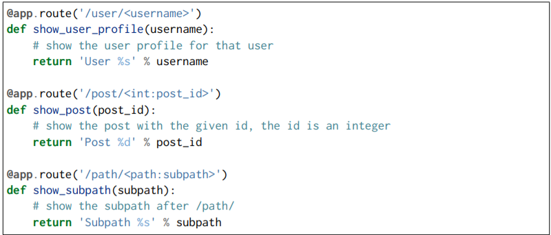

HTTP Methods:

Web applications use different HTTP methods when accessing URLs. You should familiarize yourself with the HTTP methods as you work with Flask. By default, a route only answers to GET requests. You can use the methods argument of the route() decorator to handle different HTTP methods.
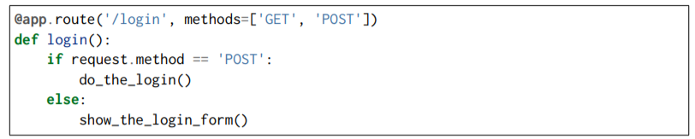

Rendering Templates:

Generating HTML from within Python is not fun, and actually pretty cumbersome because you have to do the HTML escaping on your own to keep the application secure. Because of that Flask configures the Jinja2 template engine for you automatically. To render a template you can use the render_template() method. All you have to do is provide the name of the template and the variables you want to pass to the template engine as keyword arguments. Here’s a simple example of how to render a template:
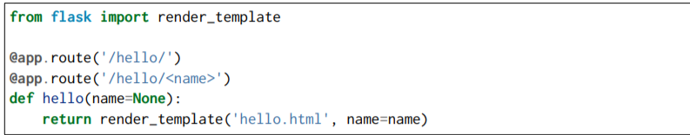

File Uploads :
We can handle uploaded files with Flask easily. Just make sure not to forget to set the enctype="multipart/form-data" attribute on your HTML form, otherwise the browser will not transmit your files at all.
Uploaded files are stored in memory or at a temporary location on the filesystem. You can access those files by looking at the files attribute on the request object. Each uploaded file is stored in that dictionary. It behaves just like a standard Python file object, but it also has a save() method that allows you to store that file on the filesystem of the server. Here is a simple example showing how that works:

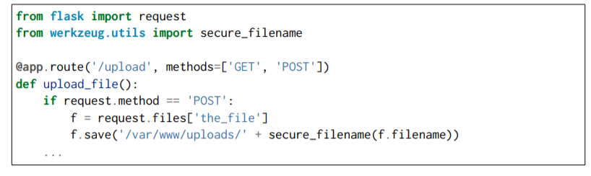
Before going into the steps that are required for the deployment let us see the folder structure inside the app

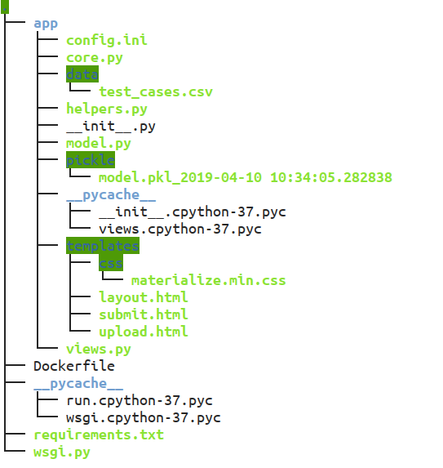

Steps for Creating the Views Code :

Step 1:
Import the required libraries. Since we want to check the folder structure we can use the editors insted of the jupyter notebook like spyder or vscode. Let us start with the __init__.py.
Here we import the Flask library and create the instance of the wsgi instance app. Also the actual code where the requirements for the application is generated we are calling it as views which is stored in the app package.

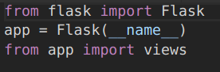

Step2: Importing the required libraries and creating the required fucntions.

i) Define the Libraries required

from app import app
import os
import pandas as pd
from flask import Flask, request, Response,render_template,flash
from flask_paginate import Pagination,get_page_args
from werkzeug import secure_filename
from joblib import load

ii) For running the model load the pickle file from the pickle folder created before and adjust the paths.

# Load the model
APP_ROOT = os.path.dirname(os.path.abspath(__file__))

model = load(APP_ROOT+'/pickle/model.pkl_2019-04-10 10:34:05.282838')

iii) For calculating the predictions of the model we need to create multiple functions to get there . Define the functions as required.

# Function to get the pages in the Flask Paginate
def get_pages(data,per_page=10,offset=0):
return data[offset:offset+per_page]

# Function to create the result
def result(APP_ROOT,model):
data = pd.read_csv(APP_ROOT+"/data/test_cases.csv")
try:
data = data.drop('y',axis=1)
data = data.drop('Unnamed: 0',axis=1)
except:
pass
data = data.reset_index(drop=True)

prediction = model.predict(data)
output = prediction
output = output.tolist()

data['prediction'] = output
cols = list(data.columns)
col=[cols[0]]+[cols[len(cols)-1]]+cols[1:len(cols)-1]
data = data[col]
outputcsv = data
return outputcsv

Step 3: Routing has to be created on the webpages based on the requirements. The plan of the webpages used some html templates. Please load the templates to the templates folder. The following are the templates. There are three templates as part of the application used upload.html,layout.html,submit.html.

Upload.html:

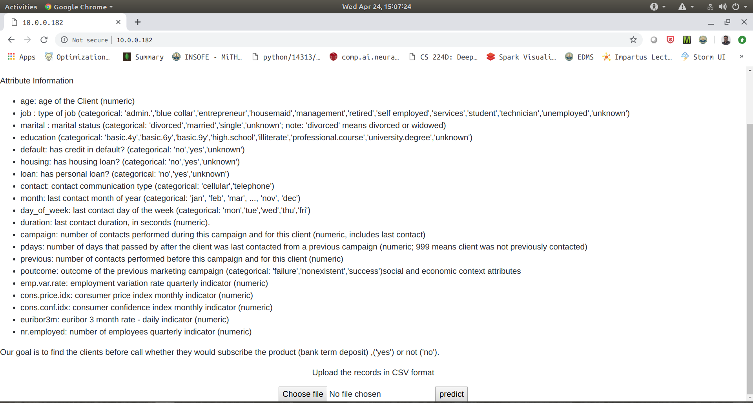

Layout.html:
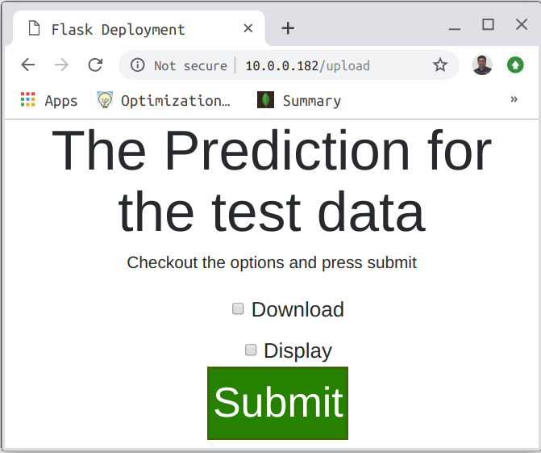

Submit.html:

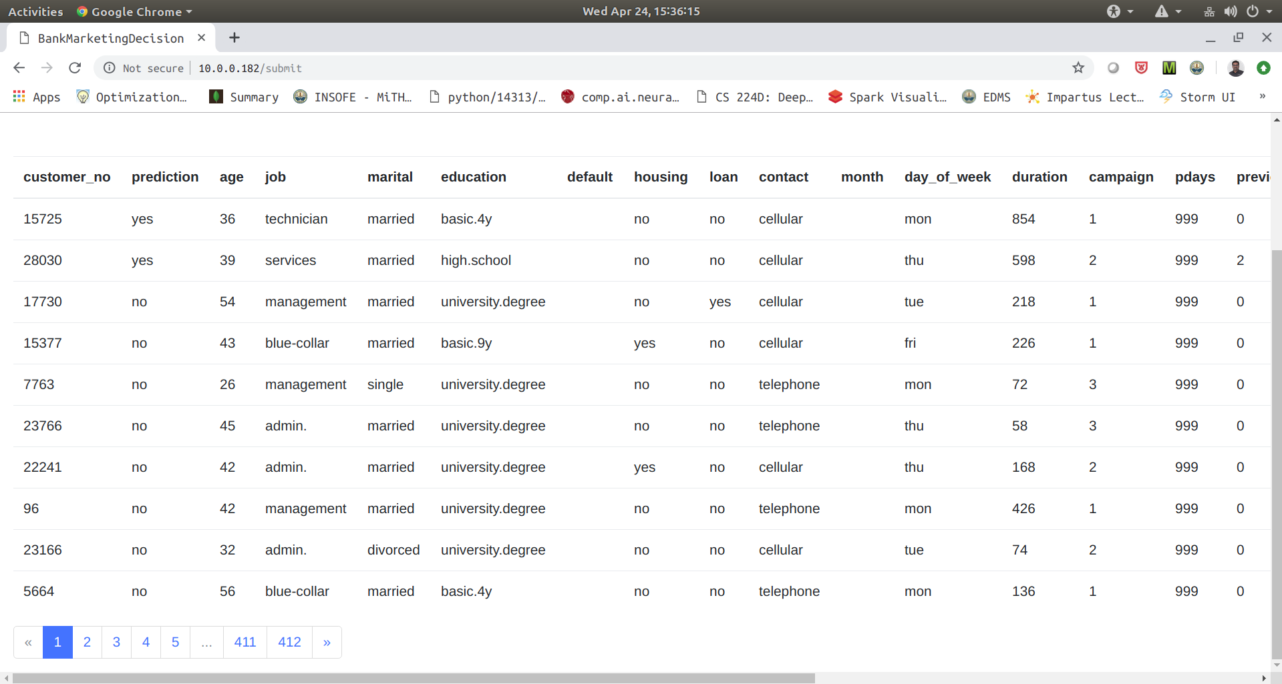

i) Loading the first page (i.e) upload

@app.route('/')
def index():
return render_template('upload.html')

ii) Loading the layout page based on the upload page inputs and store the data to the data folder which is uploaded in the first page

@app.route('/upload',methods=['POST'])
def upload():

target = os.path.join(APP_ROOT,'data/')
#print(target)
if not os.path.isdir(target):
os.mkdir(target)

file= request.files['file']

if file:
filename = secure_filename(file.filename)
destination = '/'.join([target,filename])
data = pd.read_csv(file)

data.to_csv(destination)

return render_template('layout.html')

iii) Loading the submit page and get the requests from the user whether they want to disppla the results or save the csv file

@app.route('/submit',methods=['GET','POST'])
def submit():

if request.form.getlist("download")==['on']:

print(type(request.form.getlist("download")))

outputcsv = result(APP_ROOT,model)
#outputcsv.to_csv(destination)
csv = outputcsv.to_csv()
return Response(
csv,
mimetype="text/csv",
headers={"Content-disposition":
"attachment; filename=result.csv"})

else:

print(type(request.form.getlist("display")))

outputcsv = result(APP_ROOT,model)

dat = outputcsv.to_dict(orient="records")
page, per_page, offset = get_page_args(page_parameter='page',
per_page_parameter='per_page')
total = len(dat)

pagination_pages = get_pages(data = dat,offset=offset, per_page=per_page)

pagination = Pagination(page=page, per_page=per_page, total=total,
css_framework='bootstrap4')
return render_template('submit.html',data = pagination_pages,page = page,per_page = per_page,pagination=pagination)

Step 2:

